[E140] Fan

Turn the machine upside down in the marked direction to avoid fluid flowing towards the display.

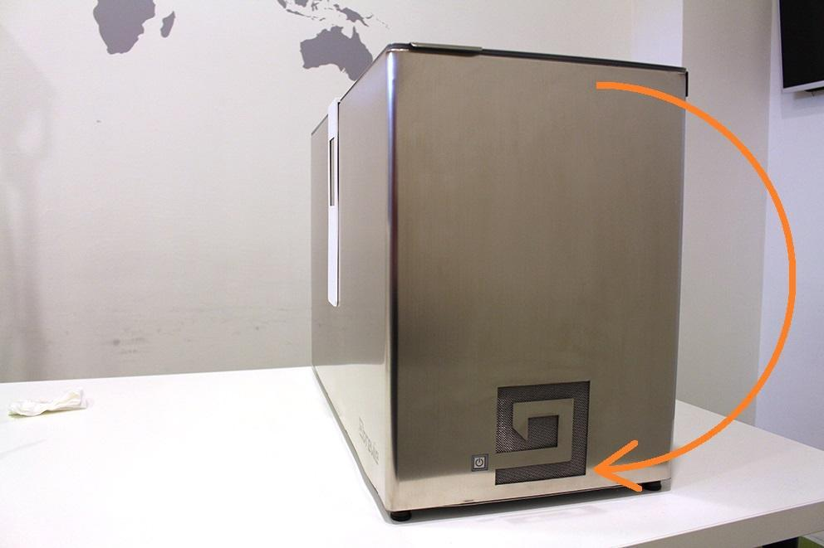

When turning the Brewie upside down, place it on two soft surfaces which leave place for the display panel. This panel CAN NOT be a weight-bearing element.

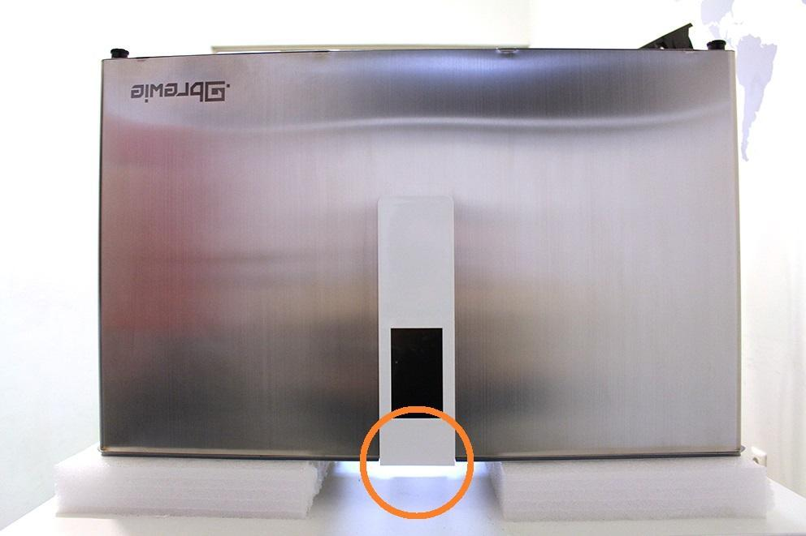

Unscrew the marked parts (2 pieces of feet with pads, 2 pieces of feet, 10 pieces of screws.

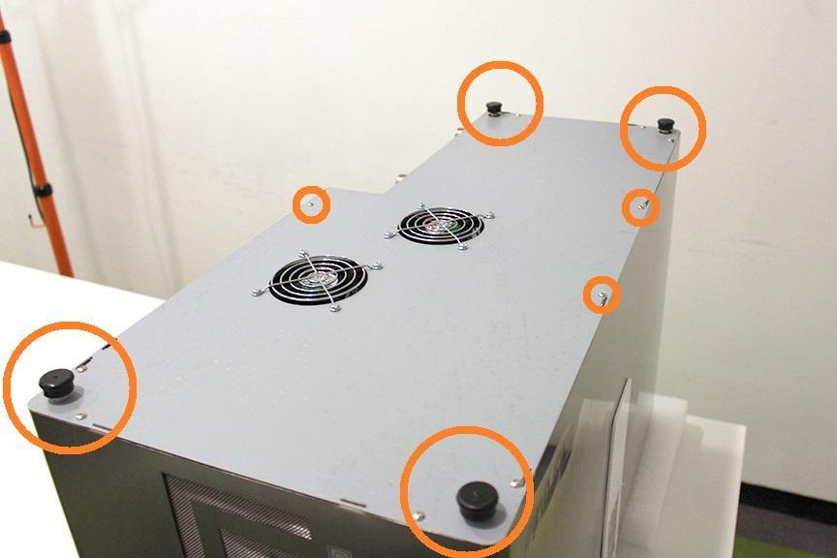

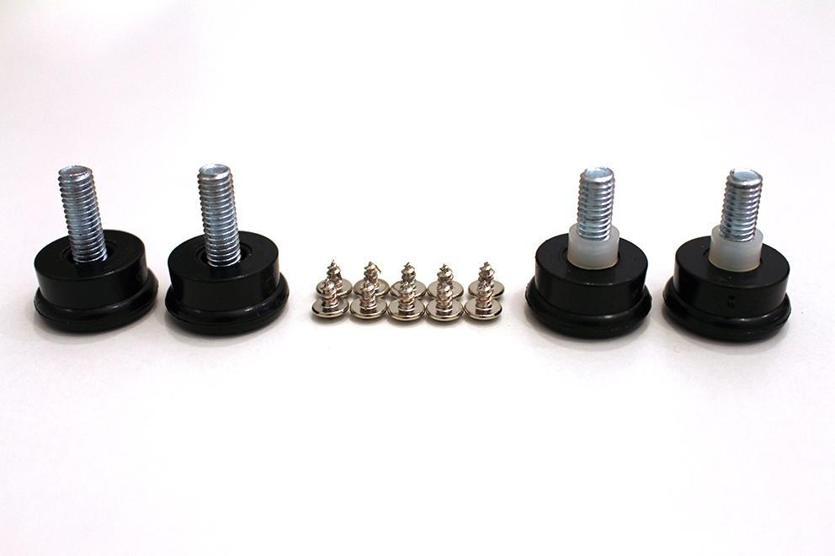

The fans can be removed by unscrewing the indicated screws and nuts and disconnecting the plugs.

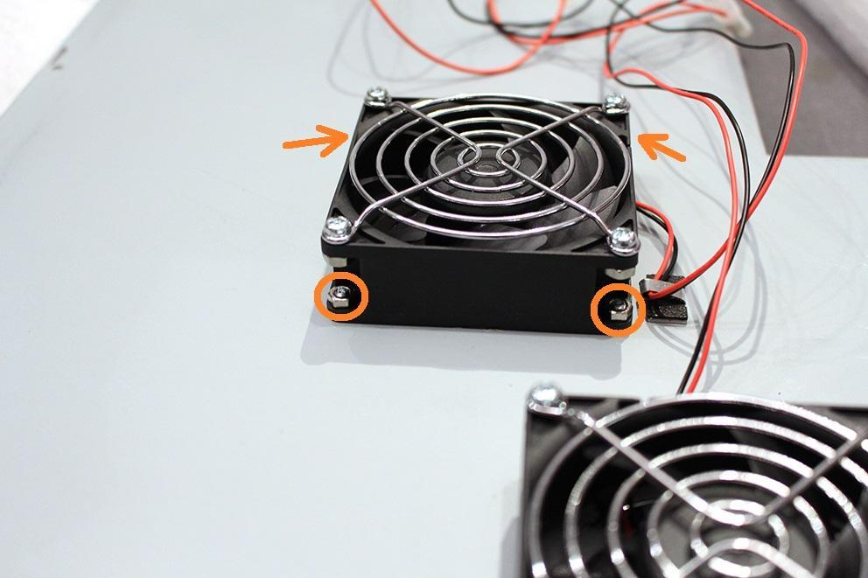

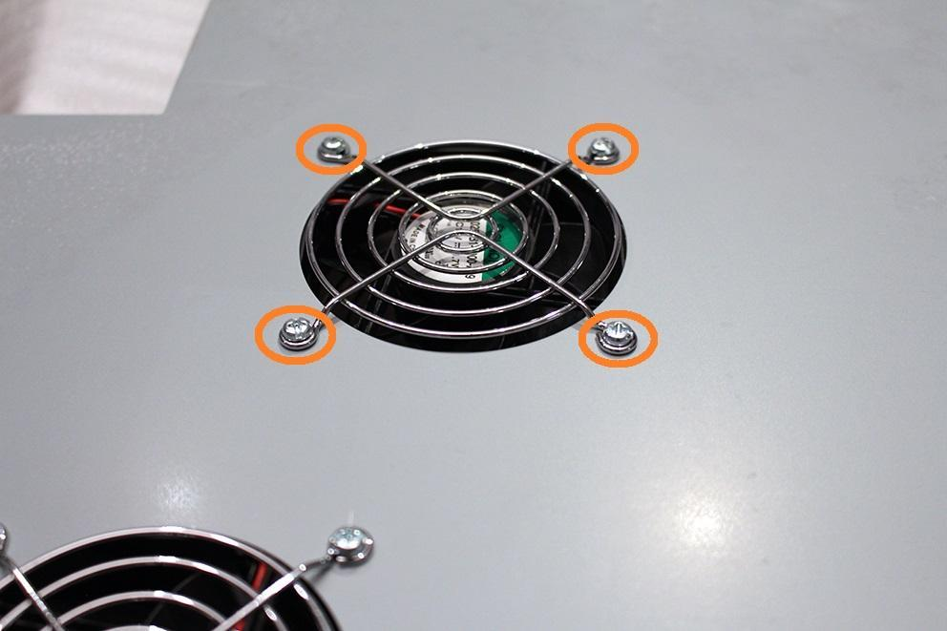

Reassemble consists of the same steps in reverse.

When reassembling, make sure that the cables do not reach into the fans.